

**PROPOSAL ON**

**A COMPARATIVE STUDY OF**

**HYBRID NETWORK (Powerline Communication AND Wi-Fi) and WIRELESS NETWORK**

**IN HOME NETWORKING.**

BY

AIDEYAN WINIFRED IWINOSA

ENG1403428

SUPERVISIED BY

DEPARTMENT OF COMPUTER ENGINEERING

FACULTY OF ENGINEERING

UNIVERSITY OF BENIN

A PROJECT PROPOSAL SUBMITTED IN PARTIAL FULFILMENT OF THE REQUIREMENTS FOR THE AWARD OF THE DEGREE OF BACHELOR OF ENGINEERING (B.ENG) IN COMPUTER ENGINEERING, UNIVERSITY OF BENIN, AND EDO STATE, NIGERIA.

JUNE, 2019

Table of Contents

CHAPTER ONE 3

INTRODUCTION 3

1.1 BACKGROUND OF STUDY 3

1.2 PROBLEM STATEMENT 6

1.3 AIMS AND OBJECTIVES 6

1.4 METHODOLOGY 7

1.5 SCOPE OF STUDY 7

CHAPTER TWO 8

LITERATURE REVIEW 8

2.1 RELATED WORKS 8

CHAPTER THREE 11

PROPOSED METHODOLOGY 11

3.1 INTRODUCTION 11

CHAPTER FOUR 12

EXPECTED RESULTS 12

4.1 PROPOSED BILL OF ENGINEERING MEASUREMENT AND EVALUATION (BEME) 12

REFERNCES 13

## CHAPTER ONE

### INTRODUCTION

### 1.1 BACKGROUND OF STUDY

Powerline communications (PLC) is a form of communication that uses electrical wiring to carry both data and alternating current (AC) electrical supply through existing electrical infrastructure. It connects computers using existing power outlets in the home, essentially transforming every electrical outlet in the building into a network connection. Power line networking is one of the cheapest forms of home networking and has a low start-up cost and minimal IT workload. And despite using power outlets it also will not have an adverse effect on home electric bills.

In 2000, the HomePlug Alliance, an industry-led organization, was formed with the scope to promote powerline networking through head option of HomePlug specifications (IEEE 1901). In 2001, the HomePlug Alliance released the HomePlug 1.0.1 specification followed in 2005 by a second release named HomePlug AV . The letters “AV” abbreviate “Audio, Video”. HPAV rapidly became the most widespread adopted solution for in-home power line communication. To meet the future market needs, in January 2012 the HomePlug Alliance published the HomePlug AV2 specification HomePlug AV2 enables Gigabit-class connection speeds by leveraging on the existing powerline wires while remaining fully interoperable with other technologies for in-home connectivity (Hybrid network IEEE 1905.). The Alliance’s AV Technical Working Group (AVTWG) defined new features at both the PHY and MAC layers. These have been introduced in the HomePlugAV2 specification based on extensive field tests conducted in real home scenarios across different countries. The field results obtained by the AVTWG validated the HomePlug AV2 claimed performance both in terms of achievable data rate and coverage. However, it is becoming increasingly difﬁcult to signiﬁcantly improve throughput by modifying this technology standards because of its signal to noise ratio. For this reason, other directions of improvement have been pursued so It is possible to use multiple technologies (e.g. Wi-Fi, PLC), as illustrated by the standardization of hybrid networks by the IEEE 1905 working group

Wi-Fi is another candidate for broadband Internet services just like the Plc because of its ease of

Operation and deployment. Wi-Fi offers an Ethernet class wireless local area network (LAN) with data rates up to 11 mbps (802.11b) and 54 mbps (802.11a and g) using the 802.11 wireless networking standard. The unlicensed 802.11 Wireless LAN (WLAN) technology provides excellent indoor wireless data services but has an inherent restriction of limited coverage area.

This paper will investigate two cost-effective and reliable options for providing in-home networks. One is the wireless LAN based on the IEEE 802.11 standard. Wireless technology is dominant in local networks; it oﬀers mobility and attractive data-rates. Nevertheless, it often leaves “blind spots” in coverage, and the network becomes saturated because of the increasing demand for higher rates and of the explosion of network applications. Today’s networks call for additional, simple technologies that can boost network performance, extend coverage, and improve quality of service .Several candidates among which powerline and Wi-Fi extenders are on the market. As the demand for combining diverse technologies increases, new speciﬁcations for hybrid networks are developed.

Hybrid network could be the PLC extended with wireless access allowing the use of mobile terminals to the end users so they can connect ubiquitously to the external data or internal control home network. This new environment where different technologies can join to provide a better broadband access. It uses the existing low-voltage (110/220 V) power lines for communication based on the HomePlug Powerline Alliance’s HomePlug Standard and Wi-Fi , which enables one to establish an Ethernet class network over these lines and also wireless connections. Power lines make a poor communication channel due to electrical noise, interference, and channel variability depending on the appliances in use. However, tests of Home plug powerline devices in some 500 homes show that 80% of outlet pairs will be able to communicate at about 5 Mbps or higher.It is a possible solution to obtain an improved high speed broadband access can be the use of a hybrid technology in an indoor environment by the IEEE 1905.1

The IEEE P1905.1Standard defines a common fabric that spans established home networking technologies and defines a common data and control Service Access Point. Packets can arrive and be transmitted over any interface, regardless of the upper protocol layers or underlying networking technology. Designed to enhance user experience and enable next generation connected services for consumers. Introduced by the 1905.1 specification is a layer between layers 2 and 3 that abstracts the individual details of each interface, aggregates available bandwidth, and facilitates seamless integration. The 1905.1 also facilitates end-to-end quality of service while simplifying the introduction of new devices to the network, establishing secure connections, extending network coverage, and facilitating advanced network management features including discovery, path selection, auto configuration, and quality of service negotiation.

High-speed wireless LANs can provide the benefits of network connectivity without the restrictions of numerous wires. Wireless connections can extend or replace a wired infrastructure in situations where it is costly or prohibitive to lay cables. Temporary installations represent one example of when a wireless network might make sense or is even required. Some types of buildings like historic heritage buildings may prohibit the laying of new wiring, making wireless networking an important alternative. And of course the "no new wires" phenomenon involving wireless, along with PLC networking has become a major catalyst for home networking and alternative broadband internet.

In 1997, the IEEE adopted IEEE Std. 802.11-1997, the first wireless LAN (WLAN) standard. This standard defines the media access control (MAC) and physical (PHY) layers for a LAN with wireless connectivity. It addresses local area networking where the connected devices communicate over the air to other devices that are within close proximity to each other. This standard provides an overview of the 802.11 architecture and the different topologies incorporated to accommodate the unique characteristics of the IEEE 802.11 wireless LAN standard. The standard is similar in most respects to the IEEE 802.3 Ethernet standard. Specifically, the 802.11 standard addresses:

• Functions required for an 802.11 compliant device to operate either in a peer-to peer fashion or integrated with an existing wired LAN

• Operation of the 802.11 device within possibly overlapping 802.11 wireless LANs and the mobility of this device between multiple wireless LANs

• MAC level access control and data delivery services to support upper layers of the 802.11 network

• Privacy and security of user data being transferred over the wireless media

This proposed project will show the advantages and disadvantages of the power line communication as its joined with the Wi-Fi technology as well as the standalone Wi-Fi technology and its extenders.

### 1.2 PROBLEM STATEMENT

Due to the growing demand of reliability in home networks, wireless and power-line communications (PLC) are combined or used separately by several vendors to deliver high rates and broad coverage without blind spots. PLC is at the forefront of home networking, as it provides easy and high data-rate connectivity. Its main advantage is coverage wider than Wi-Fi and data-rates up to 1Gbps without requiring the wiring of a new network. While the main advantage of the Wi-Fi over the Hybrid technology is the noise and self-interference. It is obvious that PLC can be a lucrative backbone for Wi-Fi. However, in the quest to provide reliable performance and cost effectiveness, some questions arise:

1. Where and when does HYBRID perform better than Wi-Fi?
2. Does PLC channel affect the Wi-Fi quality?
3. Do we use solely the Wi-Fi technology or hybrid
4. What are the diﬀerences between the two technologies

Some questions remain unanswered and so it will be the goal of this project to address them.

### 1.3 AIMS AND OBJECTIVES

* + 1. AIM

To carry out a comparative study of hybrid network (PLC and Wi-Fi) and wireless network in-home networking.

1.3.2 OBJECTIVES

1. To obtain a survey analysis of the cost of the two networks’ component.
2. To design and implement the hybrid network and the wireless network
3. To determine the most preferred network in terms of distance, signal strength and speed

### METHODOLOGY

The research is based on survey and experimental setup analysis of the hybrid network and the wireless network which shall be extensively discussed in chapter three of this research work.

The procedures that will be involved include a survey stage based on the cost of the various networks’ components, material selection(components), experimental process and performance evaluation of the coverage, throughput, reliability and signal strength.

### 1.5 SCOPE OF STUDY

The proposed research evaluates data from the survey of the cost and experimental setup of the Hybrid network and the wireless network.

The evaluation of the cost will be solely based on the survey conducted by monitoring the prices of the two networks’ components for a period of time (online and interview methods).

The performance characteristics that will be investigated will cover throughput,coverage , reliability and signal strength.

## CHAPTER TWO

### LITERATURE REVIEW

### 2.1 DEFINITION OF COMPONENTS OF THE NETWORKS.

In this study, the different components of the hybrid networks and the wireless network are discussed ranging from the Powerline networking adapter, the wireless router, the Ethernet cable and the hub.

2.0.1 Powerline Network adapter

A device that extends an Ethernet network to another room in the home or office using AC wall outlets and the building's electrical system. Powerline adapters are used in pairs; one at each end. It uses your home's mains power wires to create a network connection that - in many cases - is faster than Wi-Fi. It isn't limited to gadgets that have an Ethernet port: some powerline kits can create powerful new Wi-Fi hotspots to give you a wireless signal in rooms or areas your router can't reach.

It's simple, easy to set up and inexpensive given that it will greatly improve your home network for streaming HD TV, gaming and other data-hungry devices and services.

The best Powerline adapters are usually a better bet than Wi-Fi extenders or repeaters that merely push a weak signal further around a house. but Powerline is the fastest and can come with extra Wi-Fi hotspots built in. it is to install powerline adaptors. Plug one adapter into a power socket near your router and attach it to the router with an Ethernet cable Then go to the room where you want to hook up a device to the network, plug the second adapter into a nearby power socket, and connect another Ethernet cable from that to the device you want to get online.

That's it. It really is plug and play.

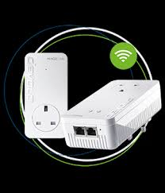

Fig. 2.1 : Powerline adapter withWi-Fi

2.0.2 Wireless Access Point

An access point (AP) is used in wireless Ethernet networks in place of an Ethernet switch. Typical APs also provide bridging functionality between wired Ethernet and wireless Ethernet hosts. There are three categories of access points: consumer APs, enterprise autonomous APs, and enterprise lightweight APs. Most technology people are at least a little familiar with consumer APs, from having such devices in their own homes. These little APs (often called "wireless routers") are used to connect together the wired and wireless clients of a home or small business network. They typically also provide a wide area network (WAN) port for connection to an Internet service provider (ISP)

Fig 2.2: SMILE Access point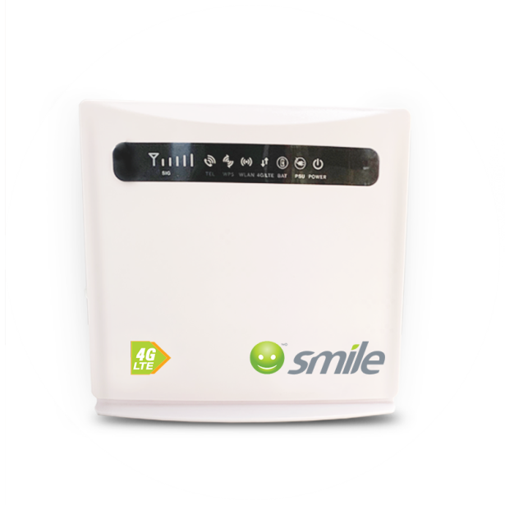

2.0.3 Ethernet Cable

UTP cables are often groups of twisted pairs grouped together with color coded insulators, the number of which depends on the purpose.  In an UTP cable, conductors which form a single circuit are twisted around each other in order to cancel out electromagnetic interference (EMI) from external sources. I will limit this study to just this two catergories of cable:

**CAT5e:**CAT5 wire was later on replaced by the CAT5e specification which provides improved crosstalk specification, allowing it to support speeds of up to 1Gbps. CAT5e is the most widely used cabling specification world-wide. Used in Ethernet-based LANs, CAT5e contains four twisted pairs. It supports 1 Gbps for 100 meters.

**CAT6:**Cat 6 cable is used mainly for computer networks reaching a GB, 1000 Mbps or one Gbps of data transfer speed (DTR) or higher. Characteristics are as follows: Consists of four pairs of copper wires, which are all utilized for data transfer Provides bandwidth of 250 MHz, speed up to 10 Gbps and may be stretched to 100 meters in length. Provides more enhanced crosstalk and attenuation protection than its previous twisted pair cable versions. It is similar to CAT5e wire, but contains a physical separator between the four pairs to further reduce electromagnetic interference. CAT6 is able to support speeds of 1Gbps for lengths of up to 100 meters, and 10Gbps is also supported for lengths of up to 55 meters.

2.0.4 Hubs

Hubs are simple network devices, and their simplicity is reflected in their low cost. Small hubs with four or five ports (often referred to as workgroup hubs) cost less than $50; with the requisite cables, they provide everything needed to create a small network. Hubs with more ports are available for networks that require greater capacity. Computers connect to a hub via a length of twisted-pair cabling. In addition to ports for connecting computers, even an inexpensive hub generally has a port designated as an uplink port that enables the hub to be connected to another hub to create larger networks.

Fig 2.3 : Hub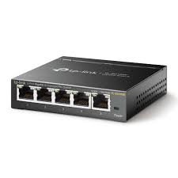

2.0.5 Wi-Fi Extenders

 Wi-Fi Extender is a device that repeats the wireless signal from your router to expand its coverage. It functions as a bridge, capturing the Wi-Fi from your router and rebroadcasting it to areas where the Wi-Fi is weak or nonexistent, improving the performance of your home Wi-Fi. Think of it in terms of baseball, where your router is an outfielder whose job is to get the ball to the catcher. A Wi-Fi extender is the shortstop that stands between the two, waiting to catch the ball and throw it in to home plate.

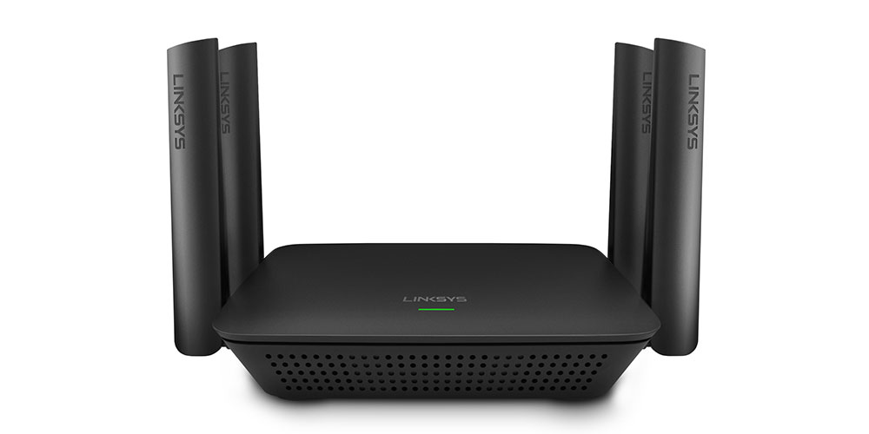

Fig 2.4 : Wi-Fi Extender

### 

### 2.2 RELATED WORKS

**2.2.1 Performance analysis of hybrid broadband access technologies using PLC and Wi-Fi**

**Oscar Andres Gonzalez,Juraj Urminsky, Miguel Calvo, Leandro de Haro (2005)**

**IMPORTANCE OF WORK**

The paper showed the performed measurements demonstrate that throughput performance of the hybrid and non-hybrid access is very similar if the communication is made in the same floor or between two floors. If the communication is made between more than two floors measurements shown that hybrid technology can improve the signal quality in locations that cannot be covered with Wi-Fi.

**LIMITATION OF WORK**

The research work was limited to just the throughput of the hybrid network, it did not cover other element parameters such as coverage and cost.

**2.2.2 A Comparative Performance Study of Wireless and Power Line Networks**

**Yu-Ju Lin, Haniph A. Latchman, and Richard E. Newman, Srinivas Katar, Intellon Corporation” IEEE Communications Magazine, vol. 41 (2003).**

**IMPORTANCE OF WORK**

The main goal of this article was to conduct a practical and theoretical comparison of the IEEE 802.11x and HomePlug 1.0 protocols and their capabilities in providing networking functionalities. From the theoretical results, it can be observed that HomePlug 1.0 and 802.11x have similar maximum efficiency. The significantly higher maximum PHY data rate of 802.11a would indicate that it should perform better than the other two standards, but in field tests its coverage was not as good.

**LIMITATION OF WORK**

Both PLC and wireless technology have significant scope for improvements over the existing standards as evaluated in this article, But the authors did not specify. They did not attempt to combine the strengths and weakness of the two technologies to achieve a better network.

**2.2.3 EMPoWER Hybrid Networks: Exploiting Multiple Paths over Wireless and Electrical Mediums**

**Sébastien Henri, Christina Vlachou, Julien Herzen, Patrick Thiran EPFL, Switzerland Swisscom, Switzerland.(2011)**

**IMPORTANCE OF WORK**

EMPoWER: This model enables them to devise a congestion controller that converges to utility-optimal allocations in a distributed fashion. It also enables them to design a new multipath-routing algorithm that computes efﬁcient combinations of paths for simultaneous use. To the best of our knowledge, this is the ﬁrst implementation of congestion-control and multipath-routing algorithms in hybrid PLC/Wi-Fi networks. EMPoWER is practical and distributed, and it offers performance close to that of optimal but-impractical algorithms.

**LIMITATION OF WORK**

The research work was able to proffer a model for the multipath of the Hybrid network, but it was not able to proffer am model for a non-hybrid network such as the wireless network. There was no practical implementation carried out during the study because of the impractical algorithms.

**2.2.4 Analysis of Wi-Fi performance data for a Wi-Fi throughput prediction approach**

**Professor Anders Vastberg, Professor Ki Wong Sung , Rius Riu Jaume.(2017)**

**IMPORTANCE OF WORK**

This thesis presents two contributions. First, a Wi-Fi data visualization tool that was developed to show physical layer metrics variation over a given time interval. Second, this thesis demonstrated an analysis of the relation between the Wi-Fi performance parameters and a Wi-Fi performance indicator, the saturated throughput. This thesis describes how to use a limited Wi-Fi parameter set to accurately estimate Wi-Fi throughput under the controlled radio communication environment by using Support Vector Machine (SVM) learning techniques.

**LIMITATION OF WORK**

It is a trade-oﬀ between complexity and estimation accuracy. Therefore, such measurement does not capture more detailed environment characteristics like packet size, 802.11n frame aggregation size or signal reﬂection (multi-path fading) which may improve prediction accuracy.

**2.2.5 Electric-Fi Your Data: Measuring and Combining Power-Line Communications with Wi-Fi. Christina Vlachou , Sébastien Henri, Patrick Thiran (2010).**

**IMPORTANT OF WORK**

They have shown that PLC can yield signiﬁcant performance gains when combined with Wi-Fi networks. They introduced an experimental framework and investigated the performance of PLC. They explored its spatial and temporal variation, delving into the diverse time-scales of PLC channel variability. They have given guidelines on eﬃcient metric estimation in hybrid implementations. They have observed that there is a high correlation between link quality and its variability, which has a direct impact on probing overhead and accurate estimations.

**LIMTATION OF WORK**

The research works focus on comparing the wireless and PLC performance investigates older speciﬁcations of PLC and Wi-Fi. The authors provide testbed measurements from 20 houses for metrics such as coverage, throughput, and connectivity but not cost

## CHAPTER THREE

### PROPOSED METHODOLOGY

### INTRODUCTION

This project will use Survey and Experimental Research methods that will include data collection and analysis, based on the proposed objectives, a subsequent design process is expressed as the suitable proposed methodology as illustrated in Figure 3.1

* Wi-Fi data measurement in both the Hybrid network and the wireless network in terms of the following parameters: performance: Throughputs (speed), coverage (distance), signal strength and reliability.
* Cost Analysis of the components required for each network, checking the market values.

Figure 3.1: Proposed Methodology

## 

## CHAPTER FOUR

### EXPECTED RESULTS

At the end of this proposed project, it is expected to be able to:

* Setup of the two networks using their various components
* Analysis of the cost of the components of the Hybrid network and the Wireless network
* Analysis of the Throughput, coverage, signal strength and reliability measured from the two network
* Also give awareness on the use of the Hybrid network using the PLC and Wi-Fi technology.

### 4.1 PROPOSED BILL OF ENGINEERING MEASUREMENT AND EVALUATION (BEME)

|  |  |  |  |  |
| --- | --- | --- | --- | --- |
| S/N | COMPONENTS | QUANTITY | UNIT  PRICE | TOTAL  PRICE |
| 1. | Data subscription | 1 month | 1,500 | 1,500 |
| 2. | Wireless access Point  SMILE | 1 | 24,600 | 24,600 |
| 3. | Powerline Adapter | 1 | 14000 | 14,000 |
| 4. | Wi-Fi extender | 1 | 19250 | 19,250 |
| 5. | Cat 5e cable | 6 | 600 | 3,600 |
| Total | | | | 62,950 |

Table 4.1: BEME

## REFERNCES

1. **Y.-J. Lin, H. A. Latchman, R. E. Newman, and S. Katar. A comparative performance study of wireless and power line networks. Communications Magazine, IEEE, 41(4):54–63, 2003.**
2. **P. Tinnakornsrisuphap, P. Purkayastha, and B. Mohanty. Coverage and capacity analysis of hybrid home networks. In IEEE International Conf. on Computing, Networking and Communications (ICNC), 2014, pages 117–123.**
3. **C. Vlachou, S. Henri, and P. Thiran. Electri-Fi Your Data: Measuring and Combining Power-Line Communications with Wi-Fi (Technical Report 210617). Infoscience EPFL 2015.**
4. **Gardner, S., B. Mark walter, and L. Yonge, “HomePlug Standard Brings Networking to the Home,” IEEE Communication Systems Design Magazine, Dec. 2000. (**[**http://www.csdmag.com/main/2000/12/0012feat5.htm**](http://www.csdmag.com/main/2000/12/0012feat5.htm)
5. **Professor Anders Vastberg KTH , Professor Ki Wong Sung Telenor ” Analysis of Wi-Fi performance data for a Wi-Fi throughput prediction approach” June 2017.**
6. **Oscar Andres Gonzalez, Juraj Urminsky, Miguel Calvo, Leandro de Haro”Performance analysis of hybrid broadband access technologies using PLC and Wi-Fi”**
7. **S. Henri, C. Vlachou, J. Herzen, and P. Thiran. EMPOWER Hybrid Networks: Exploiting Multiple Paths over Wireless and Electrical Mediums. Technical report, Infoscience EPFL, 2016. https://infoscience. epﬂ.ch/record/221483/ﬁles/tech_report.pdf.**
8. **M. K. Lee, H. A. Latchman, R. E. Newman, S. Katar, and L. Yonge, “Field performance comparison of IEEE 802.11b and Homeplug 1.0,” in IEEE Conference on Local Computer Networks (LCN’02), Nov 2002, pp. 598–599.**
9. **Oleg Logvinov ,Convergent Networks and the Future of M2M Connectivity through a first of a kind Standard:IEEE 1905.2016**
10. **Oscar Andres Gonzalez, Juraj Urminsky, Miguel Calvo, Leandro de Haro. Performance analysis of hybrid broadband access technologies using PLC and Wi-Fi. 2017**
11. ***Brian P. Crow, The MITRE Corporation In dra Widjaja, Fujitsu Network Comm mic tions Jeong Geun Kim, University of Arizona Prescott T. Sakai, IEEE 802.11 Wireless Local Area Networks 1997***
12. **. Gardner, S., B. Markwalter, and L. Yonge, “HomePlug Standard Brings Networking to the Home,” IEEE Communication Systems Design Magazine, Dec. 2000. (**[**http://www.csdmag.com/main/2000/12/0012feat5.htm**](http://www.csdmag.com/main/2000/12/0012feat5.htm)**)**
13. **Anuj V.Mundi “PLC-WIFI HYBRID BROADBAND INTERENT:DEPLOYMENT AND SECURITY”2017**

**APPENDIX**

**META-ANALYSIS TABLE**

|  |  |  |  |  |  |
| --- | --- | --- | --- | --- | --- |
| **S/N** | **AUTHOR** | **YEAR** | **TITLE** | **IMPORTANCE** | **LIMITATION** |
| 1 | Oscar Andres Gonzalez,  Juraj Urminsky, Miguel Calvo, Leandro de Haro | 2005 | Performance analysis of hybrid broadband access technologies using PLC and Wi-Fi | The paper showed the performed measurements demonstrate that throughput performance of the hybrid and non-hybrid access is very similar if the communication is made in the same floor or between two floors. If the communication is made between more than two floors measurements shown that hybrid technology can improve the signal quality in locations that cannot be covered with Wi-Fi | The research work was limited to just the throughput of the hybrid network, it did not cover other element parameters such as coverage and cost |
| 2 | Yu-Ju Lin, Haniph A. Latchman, and Richard E. Newman, University of Florida Srinivas Katar, Intellon Corporation ” IEEE Communications Magazine, vol. 41. | 2003 | A Comparative Performance Study of Wireless and Power Line Networks | The main goal of this article was to conduct a practical and theoretical comparison of the IEEE 802.11x and HomePlug 1.0 protocols and their capabilities in providing networking functionalities. From the theoretical results , it can be observed that HomePlug 1.0 and 802.11x have similar maximum efficiency. The significantly higher maximum PHY data rate of 802.11a would indicate that it should perform better than the other two standards, but in field tests its coverage was not as good. | Both PLC and wireless technology have significant scope for improvements over the existing standards as evaluated in this article, But the authors did not specify. They did not attempt to combine the strengths and weakness of the two technologies to achieve a better network |
| 3 | Sébastien Henri, Christina Vlachou, Julien Herzen, Patrick Thiran EPFL, Switzerland Swisscom, Switzerland. | 2011 | EMPoWER Hybrid Networks: Exploiting Multiple Paths over Wireless and ElectRical Mediums | EMPoWER: This model enables them to devise a congestion controller that converges to utility-optimal allocations in a distributed fashion. It also enables them to design a new multipath-routing algorithm that computes efﬁcient combinations of paths for simultaneous use. To the best of our knowledge, this is the ﬁrst implementation of congestion-control and multipath-routing algorithms in hybrid PLC/Wi-Fi networks. EMPoWER is practical and distributed, and it offers performance close to that of optimal but-impractical algorithms. | The research work was able to proffer a model for the multipath of the Hybrid network, but it was not able to proffer am model for a non-hybrid network such as the wireless network. There was no practical implementation carried out during the study because of the impractical algorithms. |
| 4 | Professor Anders Vstberg ,Supervisor: Professor Ki Wong Sung , Supervisor: Rius i Riu Jaume | 2017 | Analysis of Wi-Fi performance data for a Wi-Fi throughput prediction approach | This thesis presents two contributions. First, a Wi-Fi data visualization tool was developed to show physical layer metrics variation over a given time interval. Second, this thesis demonstrated an analysis of the relation between the Wi-Fi performance parameters and a Wi-Fi performance indicator, the saturated throughput. This thesis describes how to use a limited Wi-Fi parameter set to accurately estimate Wi-Fi throughput under the controlled radio communication environment by using Support Vector Machine (SVM) learning techniques. | It is a trade-oﬀ between complexity and estimation accuracy. Therefore, such measurement does not capture more detailed environment characteristics like packet size, 802.11n frame aggregation size or signal reﬂection (multi-path fading) which may improve prediction accuracy. |
| 5 | Christina Vlachou, Sébastien Henri, Patrick Thiran | 2010 | Electric-Fi Your Data: Measuring and Combining Power-Line Communications with Wi-Fi | They have shown that PLC can yield signiﬁcant performance gains when combined with Wi-Fi networks. They introduced an experimental framework and investigated the performance of PLC. They explored its spatial and temporal variation, delving into the diverse time-scales of PLC channel variability. They have given guidelines on eﬃcient metric estimation in hybrid implementations. they have observed that there is a high correlation between link quality and its variability, which has a direct impact on probing overhead and accurate estimations. | The research works focus on comparing the wireless and PLC performance investigates older speciﬁcations of PLC and Wi-Fi. The authors provide testbed measurements from 20 houses for metrics such as coverage, throughput, and connectivity but not cost |